|  |  |
| --- | --- |
| Canon EOS R5 (Body Only)  Máy ảnh Canon EOS R5 (Body Only)  Canon EOS R5 1 Canon EOS R5 2 Canon EOS R5 5 Canon EOS R5 3 | **Featured information:**  45MP full-frame CMOS sensor  Continuous shooting at 12 fps with mechanical shutter, 20 fps with electronic shutter  5-axis image stabilization (IBIS)  Video recording 8K 30 fps, 4K 120 fps, 4K 60 fps  Price: $ 3100  **Specifications:**  Anti-Vibration  Sensor-Shift, 5-Axis  Lens Mount  Canon RF  Sensor Format  Full-Frame (1x Crop Factor)  Resolution  47.1 Megapixels  Size photo  8192 x 5464  Image Proportions  1:1, 3:2, 4:3, 16:9  Sensor Type  CMOS  Image Format  JPEG, Raw |

**Overview:**

Canon EOS R5 - 45MP Full-frame sensor & DIGIC X image processing chip

Canon R5 owns a 45MP Full-frame sensor designed and developed by Canon itself, providing high resolution images and videos. Combined with the DIGIC X processor that previously appeared on the 1DX III, the Canon EOS R5 can provide fast data reading and processing capabilities.

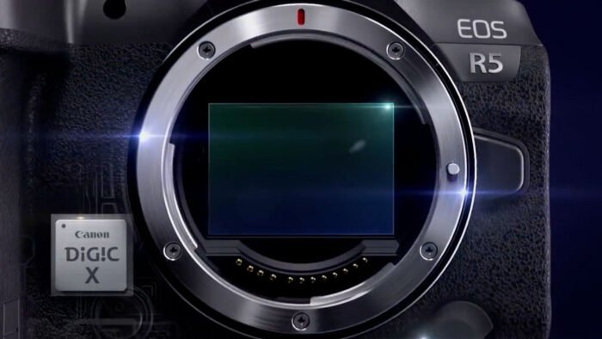

The camera possesses an ISO range of 100 - 51200 (expandable to 100 - 102400), supporting taking photos in different lighting conditions. In particular, this DIGIC move.



The Canon EOS R5 uses a second generation Dual Pixel CMOS focusing system with 1053 selectable focus points, covering 100% of the frame and providing fast, smooth focusing performance. Touch AF is also an advantage, this feature allows users to change the focus point by touching directly on the touch screen.

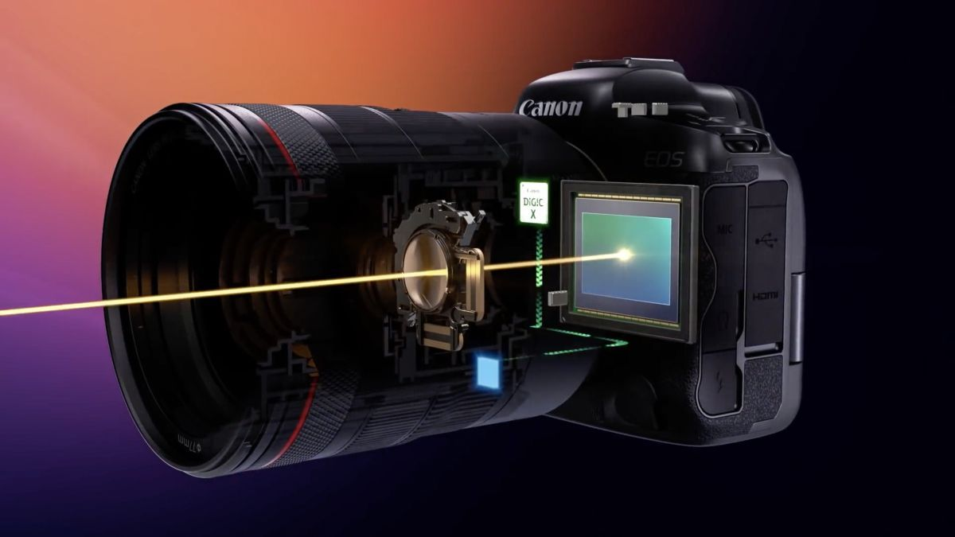

For the first time, Canon integrates IBIS image stabilization with the EOS R5 camera. By moving the sensor in five axes, it provides up to 8 stops of vibration reduction, very effective when shooting handheld with low shutter speeds. This system also works in conjunction with the optical stabilizer on RF lenses and adaptive EF lenses.